**AIRPORT MANAGEMENT SYSTEM UML DIAGRAMS**

## AIM:

To draw UML diagrams for Airport management system using Umbrello tool.

## INTRODUCTION:

In the Unified Modeling Language, a use case diagram can summarize the details of your system's users (also known as actors) and their interactions with the system. To build one, you'll use a set of specialized symbols and connectors. An effective use case diagram can help your team discuss and represent:

* + Scenarios in which your system or application interacts with people, organizations, or external systems
  + Goals that it helps those entities (known as actors) achieve
  + The scope of your system Common components include:
  + **Actors** - the users that interact with a system. An actor can be a person, an organization, or an outside system that interacts with your application or system. They must be external objects that produce or consume data.
  + **System** - a specific sequence of actions and interactions between actors and the system. A system may also be referred to as a scenario.
  + **Goals** - the end result of most use cases. A successful diagram should describe the activities and variants used to reach the goal.

## USE CASE DIAGRAM OBJECTS

* + Actor
  + Use case
  + System
  + Package

The objects are further explained below.

**Actor:**

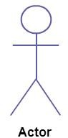

**Use Case:**

Actor in a use case diagram is **any entity that performs a role** in one given system. This could be a person, organization or an external system and usually drawn like skeleton shown below.

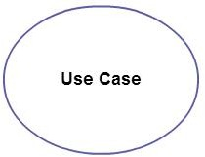A use case **represents a function or an action within the system**. Its drawn as an oval and named with the function.

## System:

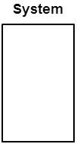

**Package:**

System is used to **define the scope of the use case** and drawn as a rectangle. This an optional element but useful when your visualizing large systems. For example you can create all the use cases and then use the system object to define the scope covered by your project. Or you can even use it to show the different areas covered in different releases.

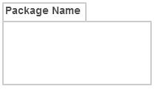Package is another optional element that is extremely useful in complex diagrams. Similar to [**class diagrams**](http://creately.com/diagram-type/class-diagram), packages are **used to group together use cases**. They are drawn like the image shown below

**1.USE CASE DIAGRAM**

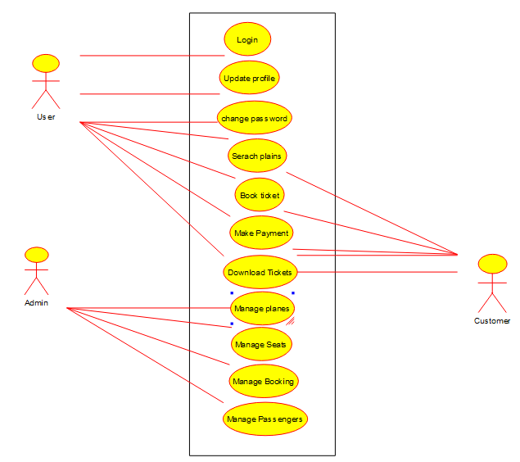

**2.SEQUENCE DIAGRAM**

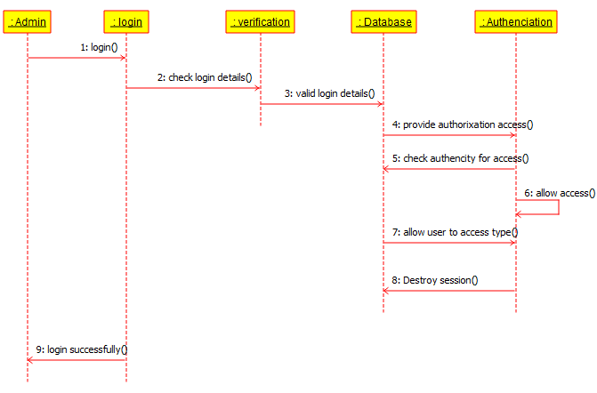

**3.CLASS DIAGRAM**

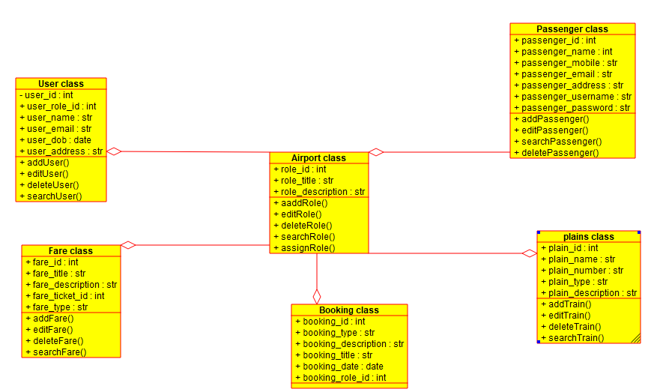

**4.ACTIVITY DIAGRAM**

